Induced Magnetic

Subject: Electrical Engineering, physical science  Related Subjects: | Grade Level(s):  Length of Lesson: | Type: Inquiry / Design / Project  Keywords:

Lesson Overview
Students will learn first-hand how a magnetic field can form from a current. When current runs through coils, this causes an “induced magnetic field”.

Lesson Focus
What is the central question or phenomenon being investigated? What problem are they trying to solve?

Lesson Objective(s) | Students will learn how to connect all the components together using wire and how the circuit essentially works.

Lesson Timing

5 minutes | Introduce the Lesson
30 minutes | ...

Materials | - Large Nail  - Magnetic Wire  - 2 AA Battery Holder  - AA Batteries  - Button Switch  - Straw  - Nails  - Washers
Instructor Prep | - Step 1
Related Resources | - List related lessons/ppts etc available from USC or outside, trusted orgs

Lesson Plan

Introduction
Introduce students to the learning goals and make connections to past and present learning experiences. Stimulate interest and prompt students to identify their own questions about the topic. This can link the lesson to real world examples, introduce associated STEM careers, and assess their prior knowledge on the topic.

- Step 1

Procedure
Nail Magnet
- Strip the ends of the battery holder
- Take the black wire of the battery holder and attach it to the switch.
- Cut 3-4 feet of magnetic wire and sand around 1 inch off the ends.
- Wrap the nail with the wire, leaving about 5 inches off the ends.
- Attach one end of the magnetic wire to the switch.
- Finally, attach the red wire of the battery holder to the remaining end of the magnetic wire
- The nail should attract the metal washers if the button is pressed down.
Straw Magnet
- Follow steps 1-3 of the Nail Magnet project.
- Cut the straw in half
- Wrap the straw with the wire, leaving around 5 inches off the ends.
- Follow steps 5-6 of the Nail Magnet project.
- Place the thin nail at the end of the straw
- The straw should suck in the nail when the button is pressed.
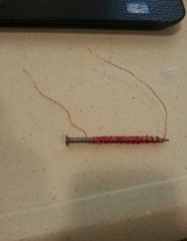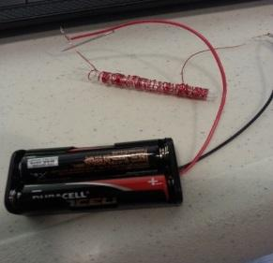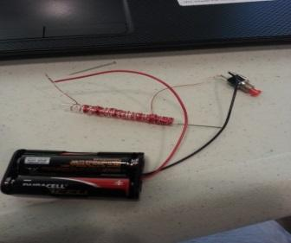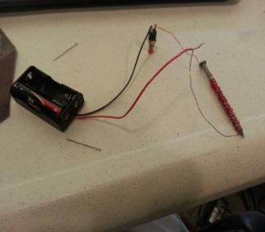

Wrap-up
End the lesson with some final discussions about what students designed/discovered. Connect their activity back to the focus question/problem, real world examples, and STEM careers.

Also include notes about any special cleanup considerations

Lesson Background for Teachers

Suggested Real-World STEM Connections
- List possible related Role Models in STEM (with details and links to more reading). Give suggestions for examples of scientists/engineers who are from underrepresented groups in STEM in related careers.
- List related real-world engineering problems and examples

Lesson Variations and Options
Include descriptions of alternative methods or ways to present things.

Explanation
Describe the background concepts and explanations behind the lesson. This can be more in depth than a teacher/instructor would actually share with students.

Key Concepts and Vocabulary
- Word 1: Grade Appropriate Definition
- Word 2: Grade Appropriate Definition

Safety Notes
- Safety instruction

